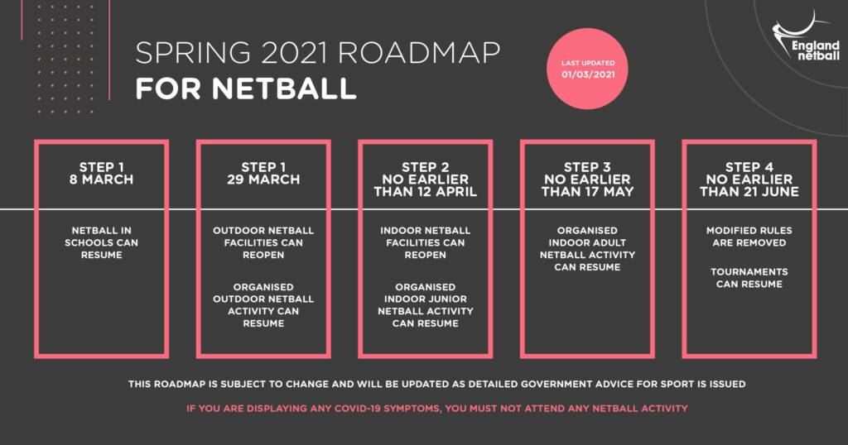

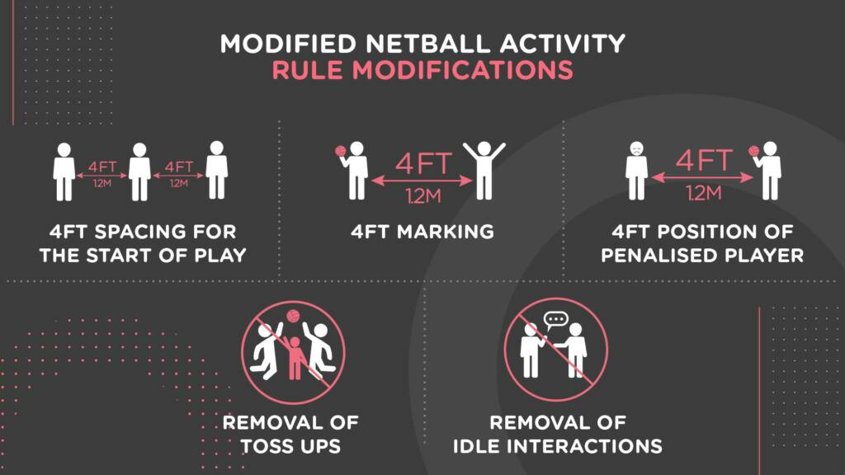

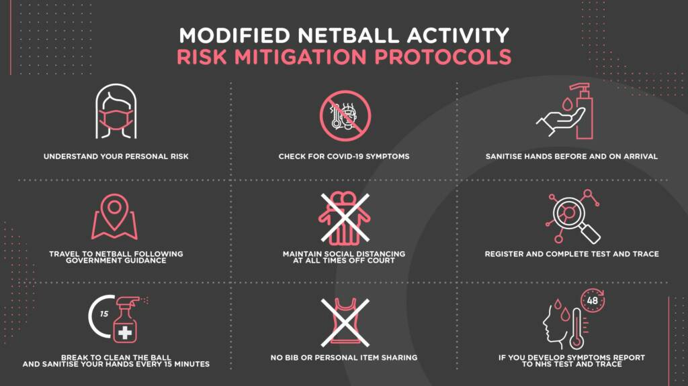

Two Counties Netball League - COVID-19 Risk Assessment – Competitive/Friendly Matches –from 17th May 2021
Location –Nusa Nottingham - Outdoors Courts

Indoor will be relooked at when Government Guidelines say we can

England Netball upon following government guidance has asked leagues to adhere to the following:
COVID risks in playing netball - Updated March 2021
Game play modification video Updated March 2021
Re Start Guidance document – Updated March 2021

There are some specific issues that are addressed in the risk assessment but for clarity please read the following Government advice to sports:
OUTDOOR
INDOOR

Additional considerations for planning to resume competitive games:

The league has considered further measures and areas during the completion of the initial risk assessment and will continue to do so as the assessment is reviewed. This includes:
- assessing the availability of players and match officials
- flexibility of rules for this season.

Covid-19 Testing:
All players have been instructed that they need to be ready and willing to book a test if they are displaying possible symptoms of Covid-19 and must not attend games or training sessions during this period. They also must self-isolate and not attend if they have been in close contact with someone who has developed symptoms of Covid-19 or someone who has tested positive for Covid-19. As a league we will pass on contact details of any player, official or spectator if requested by Test and Trace or Public Health England.

This COVID19: Risk Assessment and Action Plan document sets out the decisions taken and measures put in place to prepare for the return to competitive games and ensure the they operate in a safe way.
Existing policies and guidance continue to apply alongside the actions within this document, including but not limited to:
  - Health and Safety Policy
  - First Aid Policy
  - Safeguarding Policy
  - EN Guidance relating to COVID19

Health and Safety Risk Assessment – COVID-19
League | Two Counties Netball League | Site (s) | Nusa
Subject of Assessment | COVID-19 Measures – in preparation for competitive games from 17th May 2021
Conducted by | COVID Coordinator – Karen Carmichael | Date | 3/5/21
Details of activity | Game play, including the safe arrival and use of facilities | Persons Affected  (Who may be harmed)
 |  | Players, Match Officials, Spectators. (including parents).

Number | Hazards and Risks | Risk Level Prior to Control Measures |  |  |  | Control Measures | Risk Level After Control Measures |  |  |  | Responsibility
 |  | S x P = RR |  |  | RR |  | S x P = RR |  |  | RR
1. | Spread/contraction of COVID-19 due to interaction with a person who has symptoms of the disease, a person who may be asymptomatic or lack of information. | 5 | 3 | 15 | MEDIUM | - The league has informed players, match officials and any other visitors, including parents and Club officials, not to enter the school grounds if they are displaying any symptoms of coronavirus (following the COVID-19 guidance for households with possible coronavirus infection); regular reminders and links to updated government guidance are provided via the Clubs, Team Captains and on the Two Counties website or Face book page ;  - League committee and at least one person from each club (and others who may be regularly in attendance) will be given training on the preventative measures in place immediately prior to start of the 2020/2021 season.  - Players, officials and volunteers are briefed and consulted on game procedures;  - they have had training and briefing regarding infection control and game protocols;  - Health checks are carried out before attendance at each game using the COVID 19 Health Declaration  - all are up to date on other related guidance and support in relation to themselves and including: England Netball COVID guidance and Guidance for parents and carers on supporting children and young people’s mental health and wellbeing during the coronavirus (COVID-19) pandemic  - Playing Safe poster issued to all members.  -Players are to understand the risks and opt in using this form | 5 | 2 | 10 | MEDIUM
2. | Spread/contraction of COVID-19 due to lack of preventative measures during match days;  - Entry / Exit from the school.  - Parking | 5 | 3 | 15 | MEDIUM | Follow the Get in, Play Safe, Get Out messaging from EN here and the guidance on Safe Travel  - Car sharing is not permitted outside your bubble.  -The school QR code will be displayed and used to log attendance at the venue.  -Game times will be amended to ensure that members between matches do not cross over.  -A one way in and out will be marked at each location  -Everyone to register in using the QR code available on the door. Must be repeated for every game.  - Members are required to complete hand sanitizing or washing on entry to the school;  -Clubs are to have hand sanitizer available for team use  - Entrance doors are held open, reducing the number of occupants touching the doors; NB. Fire doors must be immediately closed after entry / exit.  - All occupants are required to wash their hands (soap/water or hand sanitizer) on entry to the school; signs will be clearly visible on entrance to remind members to do this;  - Good hand washing signage and instruction displayed.  -Members are encouraged to stagger leaving vehicles to ensure distancing.  -Wait in own vehicle until time permitted to enter.  -Courts will only have the 2 opposing team attending and the following teams must not enter until the area has been cleaned and all players / officials have left.  -Not to group together before and after game playing, and to ensure maximum distancing before and after games in line with EN guidance. | 5 | 1 | 5 | LOW
3. | Spread/contraction of COVID-19 due to lack of preventative measures during match days:  - Game play | 5 | 3 | 15 | MEDIUM | - Teams will only be in attendance with their opposing team and necessary match and team officials;  -This will not breach a maximum of 30 in attendance. If necessary roles must undertake dual roles. I.e. A sub on the bench scores.  - Match games will be conducted on outside courts, leaving a court between not in use.  Modified game play:  -Risk mitigation via game play modification will be followed by all players. Game play modification video  -poster detailing the changes will be displayed at the game.  -Reduced match lengths of 12 minute quarters with a 90 second break.  Players:  - Players are regularly reminded not to touch their or other players;  - Players reminded of good hygiene for catching coughs and sneezes;  -Players to remove themselves to allow for hand sanitizing mid game, they will be permitted back on court in line with normal rules (at the next centre pass)  -During intervals- Teams will stay in separate goal thirds, no huddles and be at least 1.2 meters’ apart.  -No shouting is permitted  -No sharing of bibs, teams should have enough to switch players positions without sharing.  -Players can only play in one game per day but can umpire additional games.  Equipment:  - Netball posts and benches will be sanitized between games in accordance with EN guidelines;  -Posts to be cleaned at the defending end  -Each team will bring a suitable match ball;  - Balls leaving court, must only be retrieved by a player of that game;  - Balls will be switched over at intervals to allow for cleaning;  -Umpires to provide and sterilized their own whistles.  -No sharing of pens, clipboards, or timers.  Match sheets  A Pack of Cards will be given or can be printed by each team and brought to the game.  These will be completed one per individual scorer – no signatures will be needed by players.  -Sheets/Cards will be photographed and returned electronically to results face book page.  Umpires & Match Officials:  - Interaction with umpires should be conducted maximizing distancing and no less than 1 metre apart.  - Umpires will ensure that they keep more than 1 metre apart from players;  - Scorers will be provided by each team and should Endeavour to keep to 2m social distancing between themselves at all times wherever possible at least one metre away from each other;  In addition, to hand washing upon arrival, any officials staying to attend a second games, must repeat the hand washing procedure;  -Timing of games to be carried by a central committee member. No sharing of timers.  -Those not playing or umpiring are recommended to wear a face mask. | 5 | 1 | 5 | LOW
 | Spread/contraction of COVID-19 during pre and post match activity | 5 | 2 | 10 |  | Nail checks should take place at a distance of 2m or more  - There should be no pre match huddle – players should remain socially distanced for any pre match team talk  - No pre match or pre quarter hands in  - No shouting or cheering  - No quarter or half time huddles  - No high fiving  - No post match hug circles or handshakes  - Any post match paperwork should be shared digitally (this could be emails or photographs)  - No post match team teas or sharing of snacks and confectionery | 5 | 1 | 5 | LOW
5. | Spread/contraction of COVID-19 due to lack of hand-washing and general poor hygiene. | 5 | 3 | 15 | MEDIUM | - Hand washing or sanitizing is recommended frequently and required at the following times:  ➢ Entry and exit from the school;  ➢ After using the toilet;  ➢ At each quarter interval;  ➢ Before and after eating;  - Unnecessary touching of the face is discouraged.  - Members are reminded to use tissues and bin them once used. If tissues are not readily available exactly when needed occupants are reminded to cough or sneeze into their arm;  - Toilets and wash stations have single use paper towels for drying hands or air dryers.  -No changing rooms are to be used. | 5 | 1 | 5 | LOW
6. | Spread/contraction of COVID-19 due to lack of adequate cleaning measures. | 5 | 3 | 15 | MEDIUM | -Our venues will be cleaned before attending.  -Between games all equipment, benches and door handles will be cleaned. | 5 | 1 | 5 | LOW
7. | Spread/contraction of COVID-19 due to insufficient First aid measures. This includes:  - Dealing with general First aid;  - Lack of trained first aiders;  - Dealing with a suspected case of Covid-19;  - Inappropriate handling / removal of clinical waste | 5 | 4 | 20 | HIGH | First Aid  - Each team has to have a designated person in attendance;  -At each location will be a COVID PPE kit in the event of first aid being needed. Containing mask, apron, gloves and waste bag.  - Any person who display symptoms of the virus during their attendance will be isolated by either being removed from court, or other players being removed, until they are able to leave.  Medical assistance can be gained from 111, or in the event of medical emergency 999;  - First aiders required to assist this person will wear PPE including gloves, and mask;  - First aiders have completed appropriate training for ‘donning and doffing’ PPE – NHS video / advice https://www.hse.gov.uk/news/face-mask-ppe-rpecoronavirus.htm  And https://www.hse.gov.uk/toolbox/ppe.htm  - PPE is disposed of in accordance with NHS COVID19 waste management guidance;  https://www.gov.uk/government/publications/covid19-decontamination-in-non-healthcaresettings/covid-19-decontamination-in-nonhealthcare-settings | 5 | 3 | 15 | MEDIUM
8. | Reporting of COVID cases |  |  |  |  | EN reporting procedures for notification process will be followed.  The league will maintain records of all those in attendance at every game on the normal match records via the team sheet. The team is responsible for all detailing everyone in attendance including scorers and umpires;  In the event of a positive test, members must use the NHS Track and Trace service to inform of those with contact;  The league will use their records and notification process for informing officials and other members;  The leagues reporting procedure will be used to monitor incidents;  -In the event of a club members having COVID or symptoms that has been in attendance at a league game, the club COVID Co-ordinator is responsible for informing both the opposing team and League Co-ordinator.  -The League coordinator will inform any impacted clubs and players via their COVID coordinator. This is in addition to the formal TEST & TRACE scheme.  -In the case of one or more positive Covid-19 cases EN will be notified via COVID@englandnetball.co.uk  - We will work closely with their local Health Protection Team who will advise on the measures required. | 5 | 1 | 5 | LOW
9. | Spread/contraction of COVID-19 due to lack of social distancing measures for spectators | 5 | 3 | 15 | MEDIUM | - Spectators are not permitted;  - The following are permitted as Officials of the League or Club;  - Scorers (one per team)  - Substitutes in netball dress  - Umpires  - Coaches (one per team)  - Safeguarding lead – for Clubs with players under 18.  - 2C Committee member  -Maximum permitted in any one team including all players, sub, scorers, club officials and parents is 13. The captain is responsible for ensuring that more do not attend.  - For players under 18, one parent / guardian is permitted;  - Parents of junior players should not congregate or watch from the court area  - All the following match protocols will apply to this group, including entry on to the register and a telephone number must be taken;  - They will be asked to maintain a 2m distance;  - All visitors who enter the match area will be verbally instructed in relevant preventative measures by the Team Captain to which they belong. | 5 | 1 | 5 | LOW
13. | Spread/contraction of COVID-19 due to external visitors gaining not socially distancing and observing precautionary measures – other members | 5 | 4 | 20 | HIGH | - Other professionals may only visit the games by pre-booked appointment and only where the COVID Co-Ordinator considers their visit essential.  - They should be fully briefed, both verbally and in writing, in the relevant arrangements in place at this time prior to undertaking the main reason for their visit. They should also sign to say that they have been fully briefed and understand the arrangements and what they need to do to comply with them. | 5 | 1 | 5 | LOW
17. | Members who are vulnerable | 5 | 3 | 15 | MEDIUM | Whilst understanding the many benefits that netball can bring, players that are vulnerable should consider whether they play competitive netball and the additional risks before participating and opt in.  Clinically vulnerable  Although this group can meet people outdoors and take part in physical activity and exercise, they should be especially careful and diligent about social distancing and hand hygiene.  Moderately at risk  If members are 60+, male, lower-socio economic status or from a Black, Asian or minority ethnic background, they are more likely to get seriously ill from coronavirus.  For latest government info, see: www.nhs.uk/conditions/coronavirus-covid-19/people-at-higher-risk/ whos-at-higher-risk-from-coronavirus/ | 5 | 2 | 10 | MEDIUM
19. | Low players due to, self-isolating or exhibiting symptoms of Covid-19 | 5 | 4 | 20 | HIGH | -The Club COVID Co-ordinator is to let 2C email know early if a player is isolating (which club and team, not the name)  - should isolation affect a team’s ability to play, they must inform the league and opposing team asap.  -League to review rules and modify to allow good attendance at games. | 5 | 1 | 5 | LOW
22. | Buildings are fit and safe to occupy | 5 | 3 | 15 | MEDUIM | England Netball guidance on booking venues will be followed;  - Appropriate cleaning is undertaken at our venue;  -RA’s for the obtained for each location. | 5 | 1 | 5 | LOW
33. | Failure to communicate the risks identified and control measures | 5 | 3 | 15 | MEDIUM | - Overall league risk assessment to be published the 2C website and facebook page.  - Clubs are to reshare and ensure their members are fully informed of measures;  Players are to watch the risk video and complete the opt-in to play;  - Players will be involved in the risk assessment creation and review;  - Player reminders on match.  - Posters at venue. | 5 | 1 | 5 | LOW
 | Failure to follow control measures | 5 | 2 | 10 | MEDIUM | The League COVID-19 Officer will regularly review the risk assessment in line with any updated guidance. England Netball will take seriously any breaches of this guidance.  Initially any concerns should be reported to one of the following;  • COVID-19 Officer  • Club Safeguarding Officer  • Other appropriate committee member  If a formal complaint is made regarding continuous, intentional breaches of this guidance and therefore the England Netball Code of Conduct, this should be done in line with point 12.2 of England Netball Disciplinary Regulations found at www.englandnetball.co.uk/governance/enjoy-ensure-entrust/ enjoy-codes-of-conduct-disciplinary-regulations | 5 | 1 | 5 | LOW
34. | Sudden partial or full suspension of games due to positive Covid-19 test/outbreak | 5 | 3 | 15 | MEDIUM | - Committee will monitor the local impact of COVID on match fixtures and communicate plans.  -Committee to follow EN guidelines are they are updated.  -Follow EN reporting procedures for notification process. | 5 | 2 | 10 | MEDIUM
35. | Data Protection Breach | 5 | 3 | 15 | MEDIUM | Records will be deleted in line with the EN guidance for Test & Trace.  Medically sensitive information will not be shared outside of the COVID officers undertaking their duties, for the avoidance of doubt, this will include external government bodies with a statutory duty and EN for monitoring.  Clubs to be responsible for the safe keeping and disposal of team sheets, once sent electrically to the League. | 5 | 1 | 5 | LOW
36. | Fire Evacuation | 5 | 1 | 5 | LOW | In the event of a fire or the sounding of a fire alarm, all in attendance are to evacuate to the Car Park by the disabled parking. Social distancing at all times  Committee member on duty is responsible for;  - sweeping the toilet block and ensuring they are empty  -Liaising with captains to ensure all are accounted for  - Liaising with the fire service  -Informing the duty officer of the school  Fire should be reported using 999. Do not enter the courts or building until advised to do so. | 5 | 1 | 5 | LOW

Guidance Notes

When calculating a Risk score for a hazard, you will need to award a score of between 1 and 5 for Severity and again for Probability, based on the following criteria:

Severity – What is the potential level of harm? Probability – What is the likelihood of harm being caused?

Severity x Probability = Risk !
Score | Definition |  | Score | Definition
1 | Minor Injuries or Illness |  | 1 | Very Unlikely
2 | ‘Lost Time’ Injury or illness |  | 2 | Unlikely
3 | ‘Over 3 Day’ Injury or Illness |  | 3 | Likely
4 | Major Injury or Illness. |  | 4 | Very Likely
5 | Fatality, Disabling Injury or Illness |  | 5 | Almost Certain

The resulting ‘Risk’ score should be no more than 25, and should give a ‘Risk Rating’ which correlates with the Risk Matrix below.

The Red / Amber / Green aspect of the table indicates the Risk Rating which should be indicated in the preceding hazard assessment table as an ‘at a glance’ indicator.

 |  |  | Risk Matrix |  |  |  |  |  |  | Score | Action Required
 |  |  | Severity | 5 | 10 | 15 | 20 | 25 |  | 1-6 | Continue to review working practices on a regular basis and implement any additional control measures required within the timescale given in the Risk Assessment.
Risk Ratings |  |  |  | 4 | 8 | 12 | 16 | 20 |  | 8-15 | Implement control measures within time scale shown in Risk Assessment and review working practices on a regular basis. Review working practices used to reduce the probability of an accident to the lowest level possible – involve employees in the consultation.
 | Low |  |  | 3 | 6 | 9 | 12 | 15
 | Medium |  |  | 2 | 4 | 6 | 8 | 10 |  | 16-25 | Do not allow work to start - review working practices Immediately. Implement all additional control measures identified in the Risk Assessment, within the given timescales. Continue to review and implement additional control measures until the probability of an accident is reduced to the lowest level possible. (employee consultation should be included in the review).
 | High |  |  | 1 | 2 | 3 | 4 | 5
 |  |  |  | Probability

Amendments or additional Control Measures
Hazards and Risks |  | Recommended Actions / Comments

